Internship Project Proposal
Name: Elie Estephan
ID: 202410877
Company Name: Statometry Data Lab
Start Date: 9 June 2026

1) Objective Description: Overall customer satisfaction and its boosting by drawing suitable strategies amongst the business processes through creating a well-designed application. Building such a customer satisfaction gap analysis system answers three questions:
- What drives satisfaction? In other words, which of the business processes are the most important for the overall brand satisfaction?
- Where do we fail? In other words, which of the processes attributes have low customer satisfaction?
- What should be fixed? In other words, which improvements have a major impact on the overall satisfaction of the brand?
What’s the gap? Gap exists in how much the process attribute(“Commitment to delivery on time” for example) is important in driving the overall brand satisfaction and how much people or customers are happy from this process in particular(“Professional staff to handle car rental logistics including insurance” process for instance is very important in driving “RentACar” brand’s overall brand satisfaction but people are not pleased enough in “Professional staff to handle car rental logistics including insurance” compared to other processes).To conclude, the gap is Importance (how much a process drives the brand) – Performance (how satisfied are the customers with that process).

2) Problem Statement:
Context: Overall brand satisfaction is influenced by several processes. For example: if a study was about customer research related to a car rental company, the process attributes in a certain section of attributes may be: “Commitment to delivery on time” , “Professional staff to handle car rental logistics including insurance”, “Satisfaction with Operations coordinator”, etc.

The Gap
For each process, there is a mismatch between the performance (the customers rating for that process based on a certain scale using one of 3 metrics: either top 2 box or either top 3 box weighted average; depending on the scale) and the importance (contribution to the overall satisfaction)

Business Need
To identify which processes to prioritize and simulate how improving them would change the overall satisfaction.

3) Action Plan: A well-developed application will be created that includes the following:
- Gap Analysis (Bi - plot)
Goal: Visualize and classify each process into tactical regions or quadrants based on its’ importance and performance.

Axes:
- X-axis: Process satisfaction/performance (from survey data)
- Y-axis: Process Importance (calculated from regression coefficients or weights)
Note: performance and importance are plotted on the graph after scaling.

The visual representation of the four quadrants:

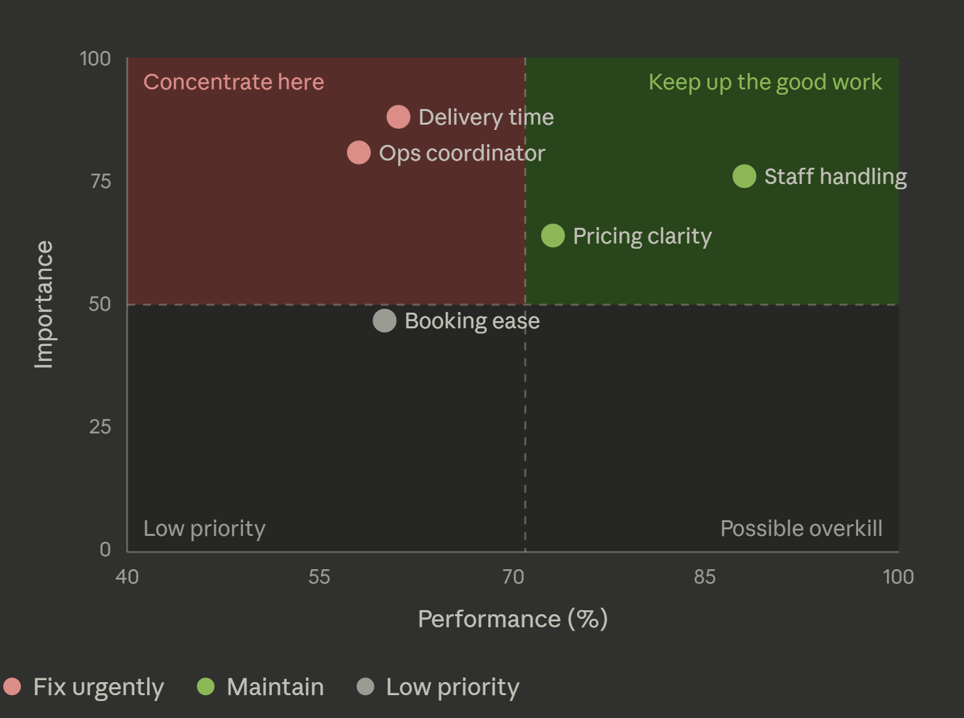

- Simulation (What-if Scenarios/Models)
There exists three complementary directions:

- Top-Down (“Top -> Bottom”): what would it take to have an overall satisfaction of…

Given: Target overall satisfaction score (e.g. 95%)
Find: The required satisfaction levels for each process attribute (statement about a certain process of a brand/company)

e.g. “to reach and overall satisfaction of 95%, ‘Commitment to delivery on time’ attribute should go from 76% to 85%’ and ‘Satisfaction with Operations coordinator’ must go from 63% to 74%’, etc. “

- Bottom-Up (“Bottom -> Top”): what happens to the overall satisfaction if…
Given: Improved process satisfaction scores

Predict: The resulting overall satisfaction score.

e.g. “If we improve ‘Commitment to delivery on time’ from 76% to 85%, the overall satisfaction score will rise from 90% to 95%”

- Optimal (Inverse / Target Optimization): what's the smartest single way to have an overall satisfaction score of …
Given: Exact target overall satisfaction score

Find: The best combination of process satisfaction scores

Main difference between the “Top-Down” and “Optimal” is that in “Top-Down”, the model finds the process scores that achieve the desired overall satisfaction score, which might be in a certain range; yet, in “Optimal”, the model solves for the single best combination of process scores that achieve the accurate overall satisfaction score set, neither greater nor less than that score (it respects bounds: can't exceed the scale).In addition, optimal model focuses mostly on the processes that have higher impact on the overall satisfaction than others.
By using simplex method constraints, we will be able to implement this optimal model.

- General Statistics
Descriptive Statistics (mean, stdev, distributions)
Correlations between processes
Iterations to reach the target values/results/scores
Results before and after simulation based on the chosen model/scenario

N.B: This application will be designed to automatically detect the number of sections holding a certain number of processes from the survey data through a naming criteria/pattern: S1_Q1, S1_Q2, S1_Q3, S2_Q1, S2_Q2…Qn_Sn.

4) Implementation (Methods & Models):
Pipeline: Survey Data -> Data Cleaning (Preprocessing) -> MLR importance weights -> Bi-Plot -> Simulation Engine -> Dashboard/Reports/Analytics

Language: The application in general will be implemented using python language as it’s very usable for such tasks involving statistical modeling, data analytics, machine learning, and high level programming.

Methods & Models:

Multiple Linear Regression (for the importance)
Why? Since multiple linear regression models overall satisfaction directly as a weighted sum of the process attributes, so each fitted coefficient is the marginal contribution of that process ,which is exactly the "importance" we want. Training it with gradient descent frames importance-finding as a machine-learning optimization problem: the model iteratively minimizes prediction error (mean squared error) until the coefficients converge.
Output: Path coefficients and variable importance
Tools: Python language is needed to create a code that uses multiple linear regression model in order to find the importance scores for each process attribute.
N.B: This type of regression is a scoring regression and not a classification one since we are predicting continuous satisfaction scores.

Simple Regression (for the simulation)
- Once we have the importance weights from the MLR model, we will use the simple regression form for predictions and simulations between overall and process satisfaction.
- Reduced Regression Form: Overall Satisfaction = β₀ + β₁ (P₁) + β₂ (P₂) + ... + βₙ (Pₙ) + ε
- This simple regression will be used in all three scenarios it just differs in the way it’s being used.

β₀: The bias which is approximately 0.96.
Bi: The regression coefficients (the lever strength of each process).
Pi: The performance score of process i.
ε: Error/Residual= Actual overall satisfaction – Predicted overall satisfaction (the part of the real overall satisfaction the processes don’t explain)

Regressions (same regression form yet used differently):
    - Phase 1: We will obtain the β coefficients from the regression model after training on the entered data. The same coefficients are going to be used in the regression form in each of the three models with no bias.

    - Phase 2: In this phase, we will apply the equation in each of the three models:

      - Bottom-up: we apply the forward propagation through plugging in scores for the processes and then estimating the final overall satisfaction score.
      - Top-down: we will rearrange the equation, set a target value for the overall satisfaction score, and then we will solve for the processes scores.
      - Optimal: we will use the regression equation as a constraint inside an optimizer (linear programming / scipy.optimize) in order to find the single best process score combination that gives the exact and accurate overall satisfaction score we have set before.

Direct plotting (for the Importance vs performance analysis – Bi-plot)
Components needed for plotting:
Importance: regression coefficients
Performance: using one of 3 metrics: either top 2 box, top 3 box, or the mean of the performance scores of each process attribute
Z-importance: It’s the standardized form of the importance scores of each process (x (imp)-mean)/stdev (the x-axes)
Z-performance: It’s the standardized form of the performance scores of each process (x (perf)-mean)/stdev (the y-axes)

5) Data Specifications
An SPSS file including questions asked to customers through a survey must be included such as:
- Overall Satisfaction (1-5/1-10 scale)
- Satisfaction question on given statements/process attributes (1-5/1-10 scale)
SPSS (Statistical Package for the Social Sciences) is a long-established, menu-driven statistical software package, now owned by IBM and it’s used widely in social science, business, and survey research to manage data. It will only be used as a data source yet analysis will be done hard coded.

6) Application Layout and structure
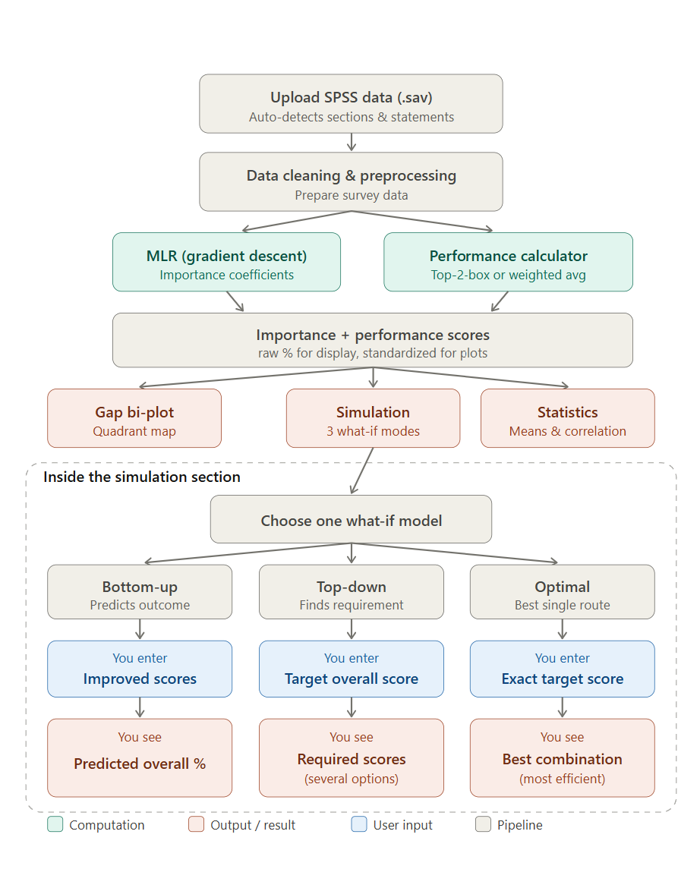

7) Application Wire Frame
https://www.figma.com/design/kpMeRFCovY3Io1MJPga2G6/Calculating-Satisfactory-Outcome-Application---WireFrame?node-id=0-1&t=1AjUQcbNsFT6bUNz-1

8) Main Goal
Strategic goal: To find where or which satisfaction gaps hurt the brand the most.
Analytical goal: To quantify importance vs performance via MLR.
Tactical goal: Using Bi-plot for the quadrant analysis.
Operational goal: To simulate several scenarios concerning overall and process satisfaction in order to plan improvements for brand/company owners before spending money.

9) Academic Benefit
As a computer science student at Antonine University, I would really benefit from working on this project during this internship since I would be applying most of my programming and AI/Machine Learning skills in the real world examples involving data analytics and statistical modeling; in addition to some UI and visualization skills

On purpose, I was told to drop all technical words why developing the ux ui of the app due to the fact the potential users are either researchers or project managers.

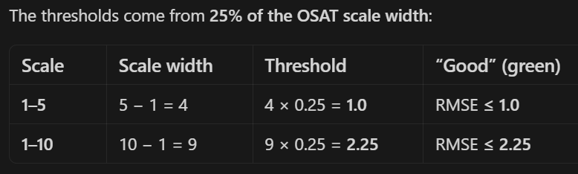

Regression Explanation of the 3 senarios:
Sure. The regression here is the actual calculator of the system. PLS-PM told you which processes matter and roughly how much — that's the importance. The regression turns that into a concrete equation you can feed numbers into and get a predicted overall satisfaction back out.
Reading the equation itself, Overall = β₀ + β₁P₁ + … + βₙPₙ + ε:
- Each βᵢ is a lever strength — how many points overall satisfaction moves when process i improves by one unit, holding the others fixed. A big β is a powerful lever.
- β₀ is the baseline (intercept) — overall satisfaction when the processes sit at their reference level.
- ε is the residual, the part real data never explains perfectly. You drop it when predicting (you're predicting the average); it's just there to acknowledge the model isn't exact.
One thing worth knowing, since your proposal lists PLS-PM and regression as two separate steps: they're actually tightly linked. PLS-PM's path coefficients are essentially the β's of a regression run on the standardized construct scores. So the cleanest design is to let this regression equation be the structural part of your PLS-PM model — fit it on the construct scores — rather than fitting a fresh, independent regression that might disagree with the importance numbers you already plotted. One equation, used consistently everywhere.
The three lines you listed are then just three ways of using that one equation:
Bottom-up — forward use. You know the process scores, so you plug them in and compute overall. "Multiple linear regression or PLS regression" just names how you estimated the β's: ordinary MLR is fine if the processes aren't too correlated, but since they usually are, PLS regression is the safer pick — it stays stable under multicollinearity, the same reasoning that pushed you to PLS-PM in the first place.
Top-down — backward use of the same equation. You fix Overall at a target (say 95) and solve for the Pᵢ. Because it's one equation with many unknowns, there are many solutions — that's the "range" from earlier. No new model, just rearranging.
Optimal — the same equation as a constraint inside an optimizer. Linear programming (or scipy.optimize) searches for the single best set of Pᵢ that hits the target exactly, while minimizing improvement effort and respecting bounds (can't exceed 100%, can't drop below current). That's what collapses the top-down range into one concrete recommendation.
A tiny illustration to make the β's tangible. Say the fitted equation is Overall = 50 + 5·P₁ + 2·P₂. Bottom-up: set P₁ = 6, P₂ = 7 → 50 + 30 + 14 = 94. Top-down for a target of 96: many pairs work (P₁ = 7, P₂ = 5.5 or P₁ = 6, P₂ = 8 …). Optimal then picks the one cheapest pair that lands on 96 exactly. Notice P₁'s coefficient is 5 versus P₂'s 2 — improving P₁ moves the needle 2.5× harder, which is precisely the kind of insight that should drive the recommendation.
And the final caveat is real: all of this clean algebra and LP works because the equation is linear. If you check the fit and overall satisfaction clearly isn't a straight-line function of the processes, you swap in random forest or gradient boosting for the prediction step. Just know the trade-off — those models predict well but you can't invert them with algebra, so top-down and optimal would then need numerical search instead of the neat equation-solving above.

